9.63: a) 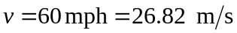
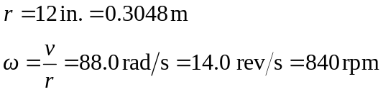
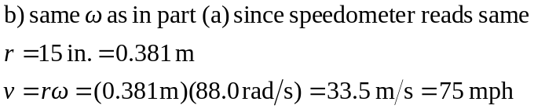
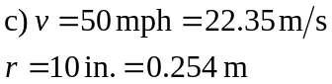
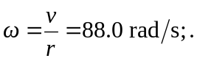this is the same as for 60 mph with correct tires, so speedometer read 60 mph.

